**Deploying the Application**

1. Open a command line (can be power shell, windows terminal) which ever has access your docker commands.
2. Change your directory to the solution folder where the docker-compose.yml is located.
3. Run “docker-compose up”
4. This should spin up api with everything it needs.
5. You should be able to browse to - <http://localhost:6969/swagger/index.html>.

**Using the API**

1. To use any of the calls you would need to do the /api/auth call first to get the bearer token, copy the token as you will need it for step 2.
   1. 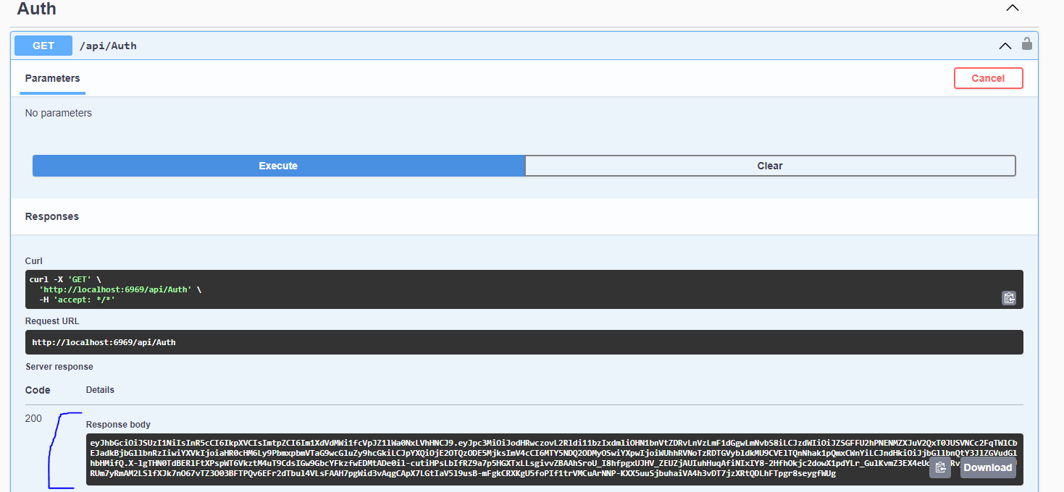
2. Once you have the token you can hit the Authorize button which will give you a popup like below, in the value box type “bearer” leave a open space and paste your bearer and hit authorize
   1. 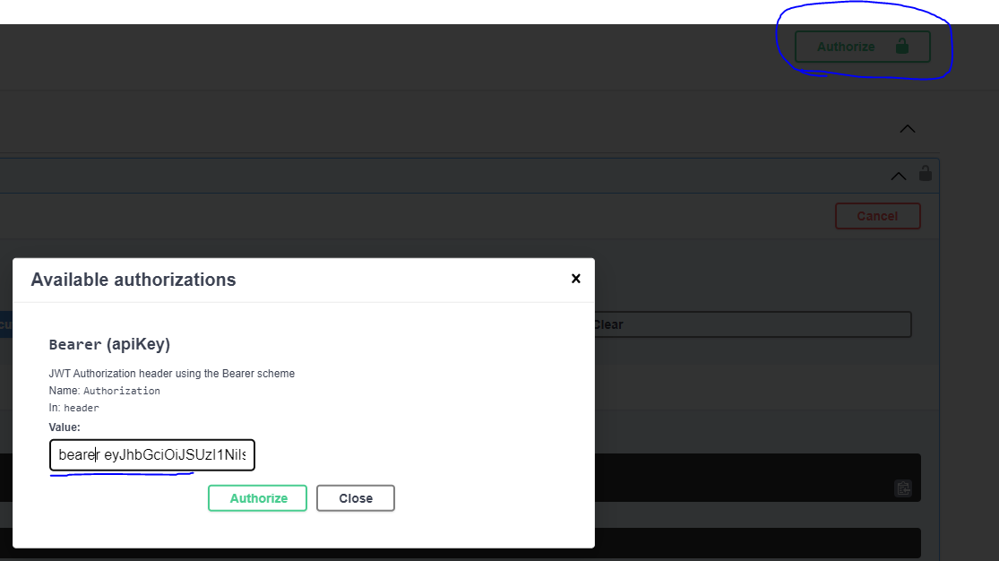
3. This will enable you to do all the calls available on the API.